|  |  |
| --- | --- |
| **Spotlight** |  |

**Background: End-User's Frustration**

Imagine you’re a passionate fan of your football club, eager to stay updated on everything being said about the team across various media. However, today’s digital media landscape is overwhelming – with podcasts, video platforms, news sites, and clips scattered across the internet. To find the specific segments where your football club is discussed, you have to navigate through multiple platforms, skim lengthy clips, and search for the few minutes that are relevant to you. It’s time-consuming, inefficient, and often leaves you missing out on valuable content.

**The Solution: An App That Saves Time and Delivers Results**

Our app eliminates the hassle of aimlessly searching for content. Using advanced technologies, it transforms the way fans interact with media. The app allows users to instantly locate the exact segments and moments in podcasts, videos, or other media that focus on their favorite team. With automatic tagging and real-time content analysis, users can jump directly to the information they care about with just one click.

It’s more than a convenience tool; it’s a personal guide through the media landscape, delivering content tailored to individual interests while creating value for all stakeholders in the ecosystem.

**The Process That Creates Value for Everyone**

**End-User Benefits**

Fans no longer waste time sifting through irrelevant content. The app ensures they:

* **Stay Updated:** Never miss a moment of importance about their favorite team or interest.
* **Save Time:** Jump straight to relevant segments without endless searching.
* **Enjoy Tailored Experiences:** Discover exactly what they love, effortlessly.

**Third-Party Distributors (like our App)**

As a distributor, the app serves as a bridge between vast media platforms and users’ specific interests. By leveraging robust APIs and sophisticated analytical tools, we create a service that organizes and filters content like never before. The result is a unique, targeted experience that drives engagement and satisfaction.

**Platforms**

Media platforms benefit from increased engagement and retention as users are drawn to relevant content faster. Improved navigation enhances platform metrics like watch time and user activity, while offering insights into what drives traffic and keeps audiences engaged.

**Content Creators**

Our app provides creators with powerful insights into user behavior, helping them understand which segments, topics, or themes resonate most with their audiences. With this feedback, creators can refine their content, increase relevance, and grow their reach organically.

**Sponsorship and Marketing Partners: Targeted Value Creation**

Our app enables brands and advertisers to reach audiences with unmatched precision. By analyzing user behavior and interests, we allow sponsors to align their messaging directly with specific consumption patterns, maximizing relevance and impact.

**How It Works for Sponsors:**

* **Granular Insights:** Access detailed analytics about which content segments drive the most engagement within your target audience.
* **Relevance in Placement:** Place ads within niches or themes that resonate directly with your brand or product.
* **Dynamic Feedback:** Adjust strategies in real-time based on insights into user behavior and engagement trends.

**Value for Marketing Partners:**

* **Enhanced ROI:** Tailored campaigns achieve higher efficiency by targeting users most likely to engage.
* **Cost-Effective Advertising:** Precise targeting reduces waste and optimizes marketing budgets.
* **Long-Term Loyalty:** Build stronger connections with audiences by being part of the content they care about most.

**Potential Value of Structured Media Consumption**

By transforming scattered and unstructured media into meaningful, actionable insights, the app unlocks new opportunities for all stakeholders. It turns fragmented content into a cohesive experience, revealing the true potential of data-driven media consumption.

**Industry-Leading Privacy and Security**

We prioritize privacy and data security through globally recognized security frameworks. Built with robust authorization models and the latest industry standards, the app ensures user information is anonymized, securely managed, and protected at every step.

**Scalable Solutions for Diverse Interests**

The app is designed with scalability in mind. It can adapt to a wide variety of topics and interests, from sports to cooking to niche hobbies. As user needs evolve, the platform grows with them, offering targeted solutions for virtually any area of interest.

**Technical Infrastructure Synergy**

Our platform uses proven tools and technologies, including APIs for data access, metadata management for content analysis, and scalable cloud platforms for seamless expansion. By integrating these technologies in an innovative way, the app offers a self-learning, efficient platform that adapts to user behavior and optimizes results for all parties.

**Summary: A Transformative Experience**

Our app redefines how media is consumed and shared. It saves time, improves engagement, and bridges the gap between user passions, content creators, and platforms. By offering targeted value to sponsors and advertisers, actionable insights to creators, and a seamless experience for users, the app creates a dynamic, win-win ecosystem.

This is more than just a content aggregator—it’s a vision for the future of personalized media consumption. A tool that connects users to their passions, unlocks new opportunities for advertisers, and empowers creators to deliver their best work.

**Future Vision: Where Innovation Meets Expansion**

Looking ahead, we aim to expand the platform with AI-driven personalization, deeper insights for stakeholders, and broader niche coverage. Our goal is to empower users to discover, consume, and engage with the content they love, while continuously evolving to meet the demands of a rapidly changing media landscape.

**Appendix: Cost of Revenue predictions**

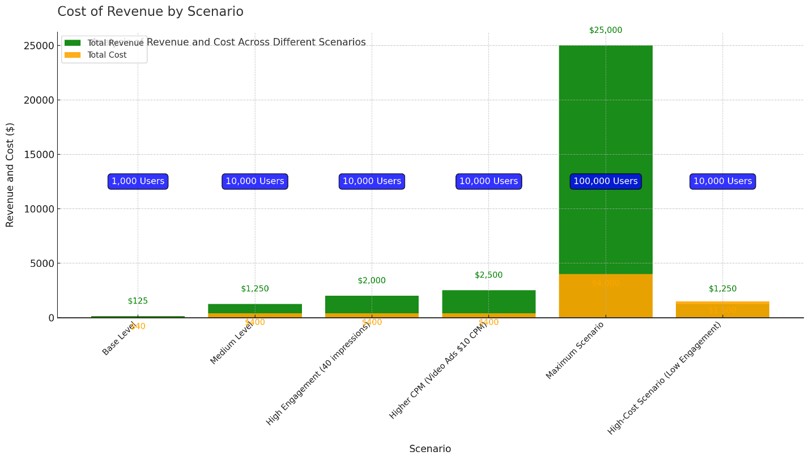

**Appendix 2:**

**Consulting Firms' Visions for the Future of the Media Ecosystem**

**McKinsey & Company**: "Personalized Media Experiences and Data-Driven Content"

Vision: McKinsey envisions a future where personalized media experiences and data-driven content are essential for creating user engagement and loyalty. They see future media consumption as dependent on delivering exactly the right content to the right audience, based on each individual’s interests and behavior patterns.

Relevance: This highlights the importance of using data to refine content delivery and create an experience tailored to user preferences. A solution that can effectively segment and highlight relevant parts of content saves time for the user and boosts engagement, aligning perfectly with McKinsey’s vision for a personalized media experience.

**Deloitte**: "Digital Media Trends and the AI-Driven Media Supply Chain"

Vision: Deloitte describes a future where AI is a driving factor throughout the entire media production chain, from creation to distribution. They foresee an industry where content can be continuously analyzed and adapted based on direct feedback from users. Deloitte emphasizes how data can inform decision-making across the ecosystem to create higher relevance and efficiency.

Relevance: This vision underscores the value of having a solution that can gather, analyze, and provide insights to content creators. By using AI to understand and act on user preferences, a dynamic feedback loop is created, forming an AI-driven supply chain where content is continuously adapted to audience demand.

**Accenture**: "Data and Analytics in the Media Industry"

Vision: Accenture emphasizes data and analytics as the key to understanding and enhancing media consumption. They advocate for an industry where media companies use advanced analytics and AI to create relevant and engaging user experiences, with the entire ecosystem optimized and customer-oriented through data.

Relevance: This underscores the importance of using data and analytics to identify and present the right content to users. A solution that provides both users and creators with the information needed to optimize consumption and production aligns well with the data-driven future that Accenture envisions.

**PwC**: "Global Entertainment & Media Outlook"

Vision: PwC highlights that future media consumers will expect immediate, seamless access to relevant content across multiple platforms. Data- and insight-driven strategies are increasingly important for creating value in the ecosystem, and companies must invest in technologies that can offer customized experiences for users.

Relevance: This supports the need for a solution that can act as a central hub where users can easily find relevant segments across different platforms. A seamless user experience and data-driven content targeting align with PwC’s vision of a future media industry where customized experiences are at the core.

**Gartner**: "The Future of the Media Ecosystem and Data-Driven Personalization"

Vision: Gartner predicts a future media ecosystem that is entirely data-driven, where content creation and consumption are integrated into a self-learning system. They stress the importance of collecting and analyzing data on an individual level to deliver personalized media experiences and advocate for close collaboration between platforms and third-party actors to achieve a cohesive user experience.

Relevance: A solution that connects various ecosystem players – platforms, third-party providers, and end-users – and enables a dynamic feedback loop for creators to optimize their content aligns perfectly with Gartner’s vision of a self-learning media ecosystem. Collecting data from users to improve and customize content is exactly what Gartner envisions as the core of future media experiences.

These visions from leading consulting firms underline the value and relevance of developing an integrated, data-driven media ecosystem. Our solution aligns with these visions by leveraging existing technologies and data to create a personalized, seamless experience for users and a self-learning process for content creators. By collecting, analyzing, and sharing data between platforms, third-party actors, and creators, a future can be built where content is produced and consumed with even higher relevance and efficiency.